Nama : M Akbar Fidyantara

NIM : 18090101

Kelas : 5C

TUGAS PERTEMUAN 5

1. Source Code

Autolod.php => application / config.php

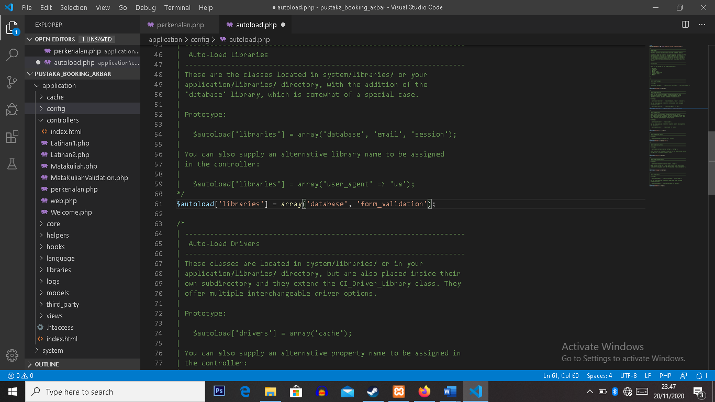

MatakuliahValidation.php => application / controller

Form-matakuliah.php => application / views

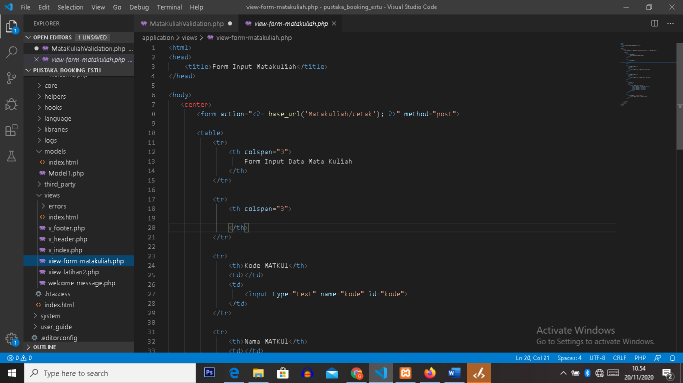

1. URL

<http://localhost/pustaka_booking_akbar/index.php/MatakuliahValidation>

1. Capture Hasil